5.2.2 Properties of the Definite Integral Worksheet

- Suppose that f is integrable on the interval . Given that and , evaluate the following definite integrals.

- Suppose that g is continuous at all real numbers and satisfies the following equations.

What is the value of ?

- Suppose that is a continuous at all real numbers and satisfies the following equations.

What is the value of ?

- Use the properties of integrals to estimate the integral .

- Use properties of integrals to demonstrate how one could determine that the following inequalities hold.

- The graph of is shown below. Evaluate .
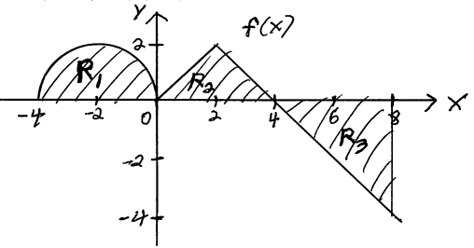

- Rounded off to one decimal place the integral is equal to one of the choices below. Use properties of integrals to circle the correct choice. Show enough work to justify your answer. Do not attempt to evaluate the integral directly.
- 0.3 | - 0.8 | - 1.1 | - 1.9 | - 2.7
- 4.3 | - 6.8 | - 7.2 | - 9.7 | - 14.9

